Internship Project

Rajath Prabhu

Bangalore

**EXPOSYS DATA LABS**

Cyber Security project

**EXPOSYS DATA LABS**

Submitted in fulfilment of the requirements for the 35-Days Internship Certification Program through online in Exposys Data Labs from 10th August – 15th September entitled “Encryption and Decryption of Text By Using Caesar Cipher” on the domain “Cyber Security” by, **Rajath Prabhu** student of BNM Institute of Technology, Bangalore.

**DATE:** 19/09/2023

**PLACE:** Bangalore

**ABSTRACT**

In the realm of information security, encryption plays a pivotal role in safeguarding sensitive data from unauthorized access and ensuring confidentiality. One of the simplest yet historically significant encryption techniques is the Caesar Cipher, which is a substitution cipher that shifts characters in a plaintext message by a fixed number of positions in the alphabet. This abstract provides an overview of the encryption and decryption processes using the Caesar Cipher. The Caesar Cipher operates on the principle of substituting each letter in the plaintext with another letter located a fixed number of positions down or up the alphabet. The encryption process involves selecting a key, which represents the number of positions to shift each letter. The key is kept secret between the sender and receiver. To encrypt a message, each letter in the plaintext is shifted forward in the alphabet by the value of the key. For example, with a key of 3, 'A' becomes 'D,' 'B' becomes 'E,' and so on. This transformed text is the ciphertext.

To decrypt the ciphertext and obtain the original plaintext, the recipient uses the same key but in reverse. Each letter in the ciphertext is shifted backward by the key value to recover the original message. This decryption process restores the original plaintext message.The Caesar Cipher is a straightforward encryption method, but it has certain limitations, such as vulnerability to brute force attacks due to its limited key space (only 25 possible keys). Despite these shortcomings, it serves as an excellent educational tool for introducing encryption concepts and techniques.

In conclusion, the Caesar Cipher represents a fundamental concept in cryptography, offering a basic understanding of encryption and decryption processes. While not suitable for securing modern sensitive information, it remains a valuable tool for educational purposes and provides a historical context for the evolution of encryption techniques. challenges.

**TABLE OF CONTENTS**

|  |  |  |
| --- | --- | --- |
| **CHAPTER NO.** | **TITLE** | **PAGE NO** |
| 1 | INTRODUCTION | 4 |
| 2 | ARCHITECTURE USED | 5 |
| 3 | AIM | 7 |
| 4 | SCOPE  FRONT END LANGUAGE   * PYTHON   FRONTEND FRAMEWORK   * TKINTER | 8 |
| 5 | SYSTEM REQUIREMENTS | 9 |
| 6 | OBJECTIVES | 10 |
| 7 | SOURCE CODE | 12-14 |
| 8 | SCREENSHOTS | 15-16 |
| 9 | CONCLUSION | 16 |

**INTRODUCTION**

In the ever-evolving landscape of information security and cryptography, the Caesar Cipher stands as an iconic and enduring symbol of the earliest methods employed to protect sensitive information. Named after Julius Caesar, who is believed to have employed this technique for secure communication during his time, the Caesar Cipher represents a foundational concept in the history of encryption.

At its core, the Caesar Cipher is a substitution cipher, one of the simplest forms of encryption, which involves replacing each letter in a message with another letter in the alphabet. The distinguishing feature of the Caesar Cipher is its use of a fixed key, which determines the number of positions each letter is shifted in the alphabet. This seemingly basic yet ingenious method can provide a degree of confidentiality and security, making it a fundamental building block in the field of cryptography.

This project report delves into the intricacies of the Caesar Cipher, exploring its history, principles, and practical applications. It aims to provide a comprehensive understanding of how this ancient encryption technique works, its strengths and weaknesses, and its relevance in today's world of advanced encryption methods and cyber threats.

In the pages that follow, we will embark on a journey through time, uncovering the origins of the Caesar Cipher and its historical significance. We will delve into the mechanics of encryption and decryption, unveiling the inner workings of this deceptively simple yet effective technique. Moreover, we will explore the broader context of cryptography, tracing the evolution of encryption from the Caesar Cipher to modern cryptographic algorithms.

By the end of this project report, readers will not only have a clear grasp of the Caesar Cipher's operation but also an appreciation for its enduring legacy in the world of cryptography. While the Caesar Cipher may no longer serve as a practical means of securing highly sensitive information, its historical importance and educational value persist, making it a compelling subject of study and reflection in the realm of cybersecurity.

**ARCHITECTURE USED:**

The architecture for a project involving the encryption and decryption of text using the Caesar Cipher can be broken down into several key components and steps:

1. User Interface (UI):

- Input Interface: The project should include a user-friendly interface where users can input the plaintext message, choose a key value for encryption, and initiate the encryption process.

- Output Interface: Similarly, there should be an area to display the encrypted text and an option to initiate the decryption process.

2. Encryption Module:

- Text Input: Accept the plaintext message from the user through the UI.

- Key Input: Obtain the key value from the user to determine the shift for encryption.

- Encryption Algorithm: Implement the Caesar Cipher algorithm to shift each letter in the plaintext message according to the key value.

- Output: Display the encrypted text in the UI.

3. Decryption Module:

- Cipher Text Input: Accept the ciphertext (encrypted text) from the user through the UI.

- Key Input: Obtain the key value used for encryption from the user.

- Decryption Algorithm: Implement the reverse Caesar Cipher algorithm to shift each letter in the ciphertext back to the original plaintext.

- Output: Display the decrypted text in the UI.

4. Security Considerations:

- The project should incorporate security features such as input validation to ensure that the key value is within the allowed range and that the input text consists only of valid characters.

- It's essential to highlight that while the Caesar Cipher is used for educational purposes, it is not suitable for securing sensitive data due to its vulnerability to brute force attacks.

5. User Experience (UX):

- Ensure that the UI is intuitive and user-friendly, providing clear instructions and feedback to the user at each step of the encryption and decryption processes.

6. Educational Components:

- Include educational materials, explanations, and tooltips to help users understand the Caesar Cipher and its operation.

7. Testing and Validation:

- Implement testing procedures to validate the accuracy of encryption and decryption processes.

- Test various key values and input scenarios to ensure the project functions as intended.

8. Documentation:

- Provide comprehensive documentation that explains how to use the project, its purpose, and any technical details.

9. Optional Enhancements:

- You can expand the project by adding features like the ability to save encrypted and decrypted messages, implement error handling, or explore variations of the Caesar Cipher.

10. Deployment:

- Deploy the project on an appropriate platform or package it for distribution, depending on the intended audience.

11. Scaling and Maintenance:

- Consider the potential for future updates or enhancements and ensure the project code is maintainable.

This architectural overview outlines the key components and steps necessary to build a project that can encrypt and decrypt text using the Caesar Cipher while providing a user-friendly experience and educational value.

**AIM**

The primary aim of this project is to delve into the historical significance and practical application of the Caesar Cipher, a classical encryption technique. We aim to explore the historical context in which Julius Caesar employed this cipher and understand its evolution in the realm of cryptography. Our project seeks to dissect the mechanics of the Caesar Cipher, unraveling how it encrypts and decrypts messages using a fixed key. We will conduct a thorough security analysis, assessing both its strengths and vulnerabilities, particularly its susceptibility to brute force attacks due to its limited key space. Additionally, we will implement the Caesar Cipher and provide demonstrations of its operation, highlighting its educational value as a foundational concept for teaching encryption basics. Comparisons with contemporary encryption methods will be made to underline the evolution of cryptographic techniques. Lastly, we will investigate historical and modern-day applications of the Caesar Cipher, showcasing its role in securing information while acknowledging its limitations in today's cybersecurity landscape.

**SCOPE OF THE PROJECT**

The scope of this project encompasses various key aspects of the Caesar Cipher. It includes a historical exploration to understand its origins and significance. We will analyze its mechanics for encryption and decryption, assess its security, implement it practically, and emphasize its educational value. Comparisons with modern encryption methods will be made, and we will investigate historical and contemporary applications. This comprehensive scope aims to provide a thorough understanding of the Caesar Cipher's historical, operational, and practical aspects within the context of information security and cryptography.

**LANGUAGES USED:**

* Python 3.10.11

**FRONTEND USED:**

Tkinter:

Tkinter is a popular Python library used for creating graphical user interfaces (GUIs). It provides a set of tools and widgets for building windows, dialogs, buttons, menus, and other GUI elements for desktop applications. Tkinter is based on the Tk GUI toolkit and is included as a standard library in Python, making it easily accessible to developers.

Key features of Tkinter include its simplicity, cross-platform compatibility, and integration with Python's object-oriented programming features. Developers can create intuitive and interactive applications with relatively little code compared to other GUI frameworks. Tkinter's widgets can be customized and styled to fit the application's design requirements.

Tkinter's versatility extends to its ability to integrate with other Python libraries and modules, making it a powerful choice for building applications with user interfaces. While it may not offer the advanced capabilities and aesthetics of some other GUI libraries, Tkinter is an excellent choice for quick prototyping, small to medium-sized applications, and educational purposes.

In summary, Tkinter is a user-friendly and beginner-friendly GUI library for Python, making it a valuable tool for developing desktop applications with graphical interfaces. Its simplicity and integration with Python make it a great choice for a wide range of projects.

**SYSTEM REQUIREMENT**

Hardware Requirements:

* Computer with either Intel Pentium processor or AMD processor.
* 128MB DDR RAM or 40GB hard disk drive

Software Requirements:

* Windows 98/2000/XP operating system.
* Microsoft Visual Studio 6.0

### **OBJECTIVES OF PHARMACY SYSTEM**

1. Understanding the Caesar Cipher: The primary objective of this report is to provide a comprehensive understanding of the Caesar Cipher, including its historical significance and its fundamental principles as a substitution cipher.

2. Mechanics of Encryption and Decryption: To thoroughly explain the step-by-step processes involved in both encrypting and decrypting text using the Caesar Cipher, with a focus on the application of a fixed key for character shifting.

3. Security Analysis: To assess the security aspects of the Caesar Cipher, including its strengths and weaknesses, and to highlight its vulnerability to brute force attacks due to its limited key space.

4. Practical Implementation: To demonstrate practical implementations of the Caesar Cipher for both encryption and decryption processes, allowing readers to gain hands-on experience and apply the technique themselves.

5. Educational Value: Emphasizing the educational value of the Caesar Cipher as a foundational concept in cryptography, highlighting its suitability for teaching encryption basics and cryptographic principles.

6. Comparison with Modern Encryption: To provide a comparative analysis, contrasting the Caesar Cipher with modern encryption algorithms, thereby showcasing the evolution of cryptographic techniques and the security demands of contemporary information security.

7. Applications: Investigating both historical and modern applications of the Caesar Cipher, illustrating its role in securing information, and acknowledging its limitations in real-world scenarios.

8. Demonstration: Offering practical examples and demonstrations throughout the report to illustrate how the Caesar Cipher can be used effectively for encryption and decryption, fostering a deeper understanding of the technique and its practical relevance.

These objectives covers the essential aspects of the Caesar Cipher, from its historical context to its practical applications and educational value.

**SOURCE CODE**

import tkinter as tk

from tkinter import ttk

def encrypt(*text*, *shift*):

*# Caesar Cipher encryption logic here*

    encrypted_text = ""

    for char in text:

        if char.isalpha():

            shift_amount = (ord(char.lower()) - ord('a') + shift) % 26

            if char.isupper():

                encrypted_text += chr(ord('A') + shift_amount)

            else:

                encrypted_text += chr(ord('a') + shift_amount)

        else:

            encrypted_text += char

    return encrypted_text

def decrypt(*text*, *shift*):

*# Caesar Cipher decryption logic here*

    decrypted_text = ""

    for char in text:

        if char.isalpha():

            shift_amount = (ord(char.lower()) - ord('a') - shift) % 26

            if char.isupper():

                decrypted_text += chr(ord('A') + shift_amount)

            else:

                decrypted_text += chr(ord('a') + shift_amount)

        else:

            decrypted_text += char

    return decrypted_text

def main():

    def encrypt_text():

        text = text_entry.get()

        shift = int(shift_entry.get())

        encrypted_text = encrypt(text, shift)

        result_text.delete(1.0, tk.END)

        result_text.insert(tk.END, encrypted_text)

  def decrypt_text():

        text = text_entry.get()

        shift = int(shift_entry.get())

        decrypted_text = decrypt(text, shift)

        result_text.delete(1.0, tk.END)

        result_text.insert(tk.END, decrypted_text)

    window = tk.Tk()

    window.title("Caesar Cipher Encryption and Decryption")

    label = ttk.Label(window, *text*="Choose an option:")

    choice = tk.StringVar()

    text_label = ttk.Label(window, *text*="Enter text:")

    text_entry = ttk.Entry(window)

  shift_label = ttk.Label(window, *text*="Enter shift value:")

    shift_entry = ttk.Entry(window)

    encrypt_button = ttk.Button(window, *text*="Encrypt")

    decrypt_button = ttk.Button(window, *text*="Decrypt")

    result_text = tk.Text(window, *height*=5, *width*=40)

    label.grid(*row*=0, *column*=0, *columnspan*=2)

    text_label.grid(*row*=2, *column*=0)

    text_entry.grid(*row*=2, *column*=1)

    shift_label.grid(*row*=3, *column*=0)

    shift_entry.grid(*row*=3, *column*=1)

    encrypt_button.grid(*row*=4, *column*=0)

    decrypt_button.grid(*row*=4, *column*=1)

    result_text.grid(*row*=5, *column*=0, *columnspan*=2)

    encrypt_button.config(*command*=encrypt_text)

    decrypt_button.config(*command*=decrypt_text)

    window.mainloop()

if __name__ == "__main__":

    main()

**SCREENSHOTS**

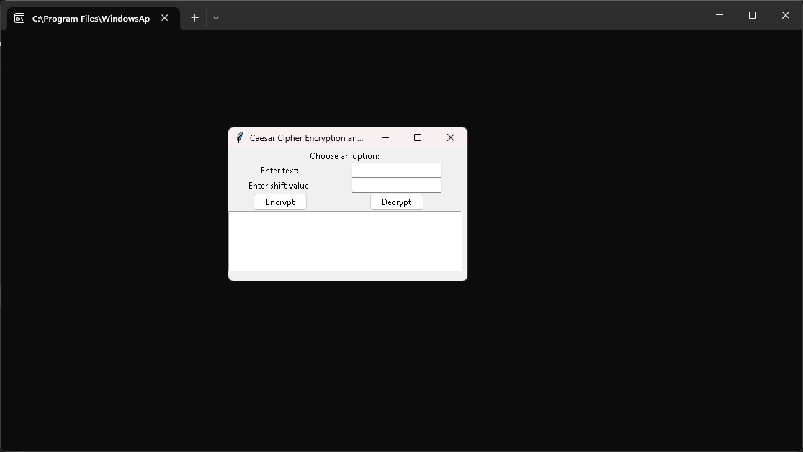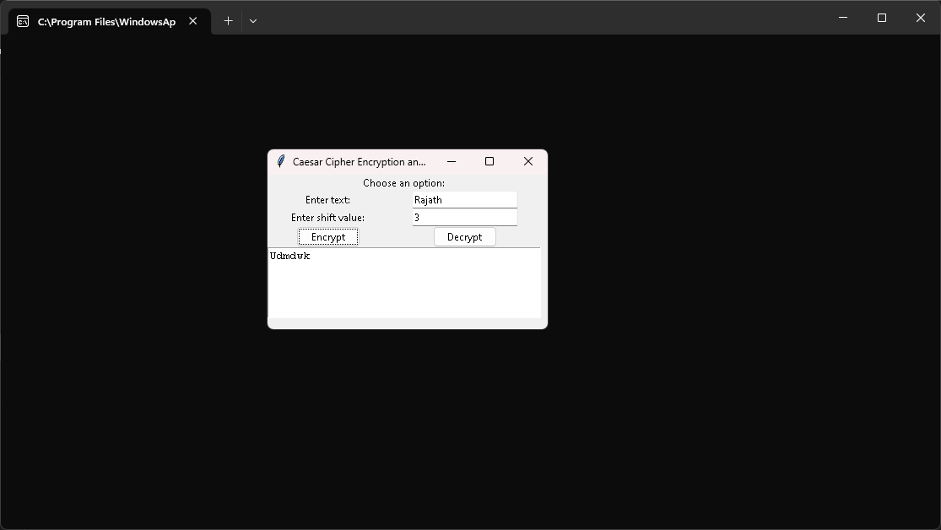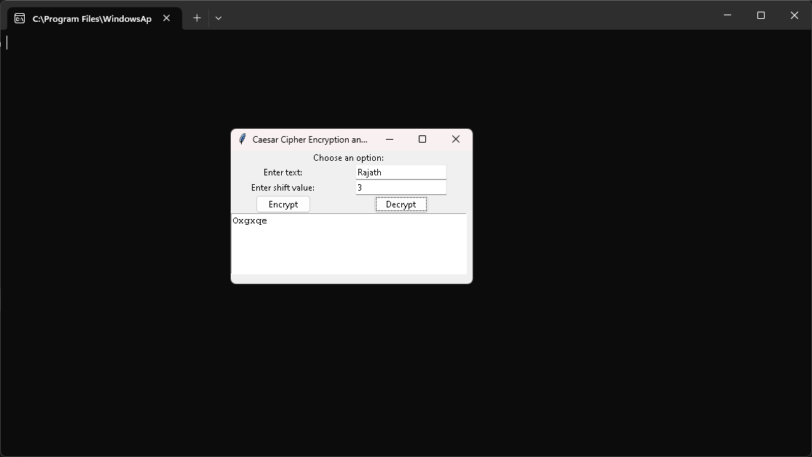

**CONCLUSION:**

In conclusion, this project has provided a comprehensive exploration of the Caesar Cipher, shedding light on its historical significance, mechanics, security aspects, and practical applications. Through this journey, several key takeaways emerge:

First and foremost, the Caesar Cipher, although a rudimentary encryption technique, serves as a critical stepping stone in the world of cryptography. Its simplicity makes it an excellent tool for educational purposes, allowing learners to grasp fundamental encryption concepts and the importance of key management.

The project highlighted the Caesar Cipher's operation, demonstrating how it encrypts and decrypts text by shifting characters based on a fixed key value. However, it is crucial to acknowledge its limitations, particularly its susceptibility to brute force attacks due to its restricted key space. In today's sophisticated cybersecurity landscape, the Caesar Cipher is insufficient for safeguarding sensitive information.

Nevertheless, our exploration showcased the historical and modern applications of the Caesar Cipher, underscoring its role in securing information and its continued relevance in certain contexts. From its use by Julius Caesar for military communications to its application in simple encryption tasks, the Caesar Cipher has left an indelible mark on the evolution of cryptography.

In addition to its practical aspects, this project emphasized the educational value of the Caesar Cipher. It serves as an accessible entry point for individuals keen on understanding encryption basics and cryptographic principles. Through our project, we've strived to offer both insight and practical experience, making the learning process engaging and enlightening.

As a final note, the Caesar Cipher project underscores the dynamic nature of cryptography. While the Caesar Cipher remains historically significant and pedagogically valuable, it has been surpassed by more robust encryption methods in contemporary cybersecurity. This underscores the importance of continuously evolving and adapting cryptographic techniques to meet the ever-changing demands of information security.

In summary, the Encryption and Decryption of Text Using Caesar Cipher project has been an enlightening journey into the world of cryptography. It has equipped us with a deeper understanding of this ancient encryption technique, its applications, and its place in the broader landscape of information security. It serves as a reminder that while we celebrate the past, we must also embrace the future in the ongoing pursuit of secure communication and data protection.

**THANKYOU.**